Lime Class medium term planning for parents – Spring term second half 2021
Year 5 Year 6 learning for both year groups
Free home learning resources https://www.bbc.co.uk/bitesize/levels/zbr9wmn https://whiterosemaths.com/homelearning
https://www.twinkl.co.uk/resources/parents

Maths
Statistics interpreting charts / reading and interpreting tables / timetables / line graphs / pie charts https://whiterosemaths.com/homelearning/year-5/week-6-statistics/ https://www.twinkl.co.uk/resource/t2-m-1825-year-5-statistics-tables-maths-mastery-powerpoint
Using the WhiteRose small steps videos at home, years 5 and 6 will recap or be introduced to a variety of statistical data collection and representation formats. Look on Bitesize or Twinkl as additional sources of activities. Can you…Create your own statistical charts – how many pieces of rubbish do you find on a walk? How many pieces of plastic do you use each day over a week? How many are used in the kitchen? Bathroom?
Religious Education
creation stories 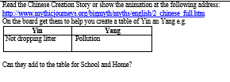

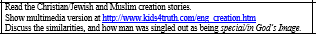
Looking at different creation stories from around the world, how are they different and how are they the same? We learn that the Jewish / Christian / Muslim stories are all basically the same, with humans created to look like God (‘in God’s image’). Can you…write your own verse to All Things Bright and Beautiful. Draw up a yin /yang chart after looking at the Chinese creation story. Write a careful, thoughtful piece about the balance of good and bad in the world (what makes’ good’ good and can we have one without the other.) Explore these sites then create a powerpoint or chatterpix on the story you like best:

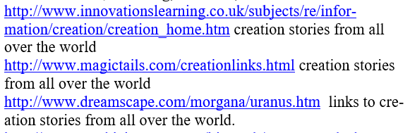

Music
Playing and performing solo, using voice and body percussion. Improvising to explore musical dimensions of pulse, rhythm, pitch, beats (in a bar) and using and understanding musical notation. Learning about harmony by singing in canon and thirds, learning how to harmonise and exploring the beauty of chords and bass lines.
Look on classroom.thenational.academy (oak national academy) for ks2 music Pulse and metre1 and Harmony
Can you create your own percussion (tap an upturned pan or a glass bottle or even the table, shake a plastic tub of rice or pasta) for the beat of your favourite song? Sing a simple canon with someone in your family – London’s Burning is always good, or teach them Bele Mama from the first video of Oak Academy ‘Harmony’.

Geography
Natural resources and biomes. What are the world’s natural resources and how have these changed? What resources do we have compared with another country and how does exploiting these resources cause problems?
Look on oak national academy ks2 Geography ‘Natural Resources’ and ‘Biomes’
Can you devise a better use for resources in your own home? Create a double page spread of ‘’instead of this, do that, so that’’ for items or actions in your home, for example, instead of using more energy to heat my home, I could put on a warm jumper so that I use my own body heat instead of more electricity or gas which contributes to global warming. Instead of throwing away old vegetables, I could make a soup, which stops waste. Make your own biome using a plastic bottle https://earthobservatory.nasa.gov/biome/hobuildrainforest.php
Create a double page spread to explain a biome. Choose anything you like: desert, rainforest, tundra, savannah.. 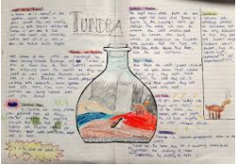

Computing
Use a range of software to design and create content.
Can you…Download the scratch app (free) and make your own designs for programmes. Present your maths statistics and information.
English
Read every day! Use your Getepic site. Can you read for 20 minutes on Getepic every day? www.getepic.com

Spellings Use the year 5/6 list of spellings. Can you learn 3 new spellings every day?
Writing Narrative writing Using oakacademy / ks2 / English / The Highwayman https://www.youtube.com/watch?v=ryu1JZiSbHo
Practise writing speech, using apostrophes, using prefixes, writing adverbial complex sentences and generating vocabulary to write openers, build-ups and finallu a free write narrative.

DT
Understand and apply the principles of a varied diet, looking at where our food comes from and how to combine ingredients to make a healthy diet.
Looking at oakacademy / subjects / DT / cooking and nutrition
Can you combine ingredients to make a healthy soup? Develop your skills to make pancakes, understanding the changes that are happening to some ingredients as they are combined or cooked. Can you design a dish to celebrate coming back to school?

Art
Improve understanding of art and design techniques. Look at the unit on oakacademy / ks2 / subjects / art and design / photography
Can you use a phone to go outside and take a photograph of a church door, standing right underneath and pointing the phone up to the sky. Look at how the perspective changes when you look at something in a new way. Use your photograph – or any perspective photograph you like – to do the art activities , including editing it to change the final image. Take another photograph of the church door – or any door you find interesting and create a mixed media picture.

