Medium Term Planning for parents (term): Reception, Year 1, Year 2/ Y1 and Y2 when tasks are the same
Topic-Japan
Twinkl Parent Hub- free home learning activities
https://www.twinkl.co.uk/resources/parents

Maths  EYFS  White Rose Links  To 20 and beyond, First, The, Now.  https://whiterosemaths.com/homelearning?year=early-years  Oak National Academy Links-Numbers within 20  https://classroom.thenational.academy/units/numbers-within-20-edc2  https://classroom.thenational.academy/units/depth-of-numbers-within-20-16d1  KS1  Y1  Multiplication and division  Unit: Multiplication and division | Teacher Hub | Oak National Academy (thenational.academy)  Fractions  Unit: Fractions | Teacher Hub | Oak National Academy (thenational.academy)  Y2:  Fractions  Unit: Fractions | Teacher Hub | Oak National Academy (thenational.academy)  Measurement- Length  Unit: Measures: Length | Teacher Hub | Oak National Academy (thenational.academy) | Religious Education-  Judaism  Use the links to find out more about Judaism  https://classroom.thenational.academy/units/hannukah-7836  https://classroom.thenational.academy/units/judaism-7011  https://www.bbc.co.uk/bitesize/topics/zqbw2hv/resources/1  Make a Menorah or a Dreidel. | English  Focusing on sounds ear, ure, igh, air, er. Practice forming these sounds and writing words including these sounds using sand, paint, chalk, flour-whatever you like! Can you make any words with these letters e.g., hair, hear, rubber, dinner, night, light.  Phonics with Geraldine the Giraffe https://www.youtube.com/channel/UC7sW4j8p7k9D_qRRMUsGqyw  Phonicsplay https://www.phonicsplay.co.uk/resources/phase/3  BBC Bitesize https://www.bbc.co.uk/bitesize/topics/zvq9bdm  Listen to some Haiku poems from Japan. Have a go at performing and writing a Haiku poem. https://www.kidzone.ws/poetry/haiku.htm  Write a list of Japanese animals, food or famous places.  Y1 and Y2  Y1- Log on to Phonics Shed and read books from Chapter 4a to practise known graphemes  Y1 and Y2- log onto Spelling Shed to access spellings at stages 1 and 2  Click on the link to listen to our class story-The Boy from the Dragon Palace  "The Boy From the Dragon Palace" retold by Margaret Read MacDonald, read by Ms. Hannah - Bing video  Write your own version of the story. What would you wish for?  Write a description of The Dragon King’s Palace  Explore Japanese tea ceremonies. Create your own and photograph it. Write a set of instructions informing someone else how to create one.  Japanese Tea: Eight Centuries of Tradition (Kyoto Pref.) | Japan Heritage  Explore haiku poetry. Try writing your own poem! Rehearse and record your poem, then send it into school to share with the class. https://www.kidzone.ws/poetry/haiku.htm
Physical Education-
EYFS: Take part in some Japanese Otedama games https://www.activityvillage.co.uk/otedama-games

Multi skills Activities
Unit: Multi skills activity | Teacher Hub | Oak National Academy (thenational.academy)

Art
EYFS: Draw yourself as a Japanese Manga Character! https://www.youtube.com/watch?v=rnpd3WO7ZRE
Paint, make or draw a Koi Fish using a medium of your choice. 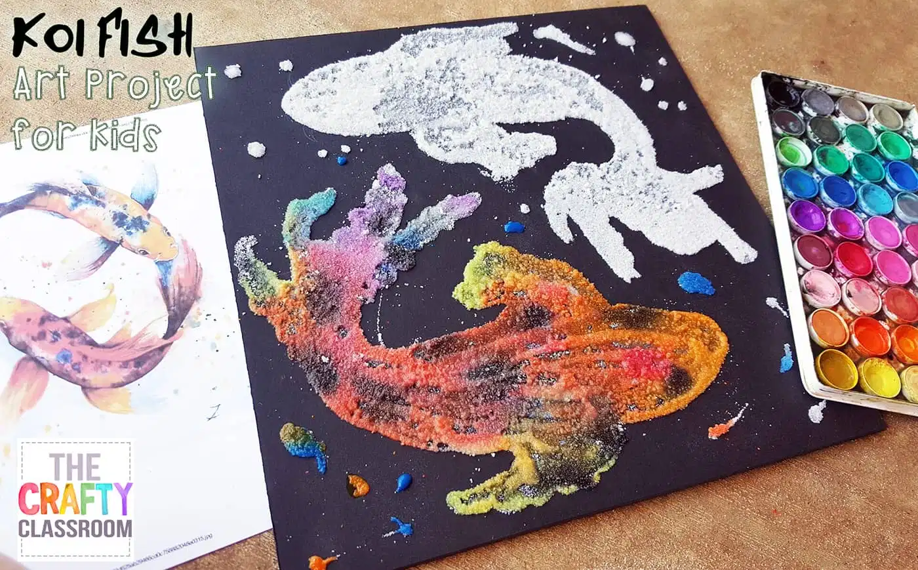

Y1 and Y2

Create a blossom tree painting
Blossom Tree Painting (activityvillage.co.uk)
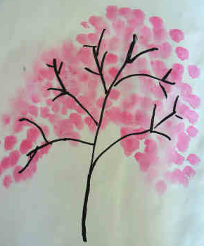

Decorate a paper lantern
Decorate A Paper Lantern (activityvillage.co.uk)
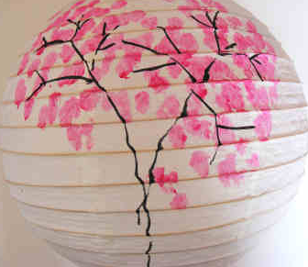

Design and Technology
EYFS: Try some simple origami.
https://www.activityvillage.co.uk/japan-crafts

Y1 and Y2
Create koinbori kites
DIY Mini Koinobori - Japanese flying carp DIY - Squirrelly Minds
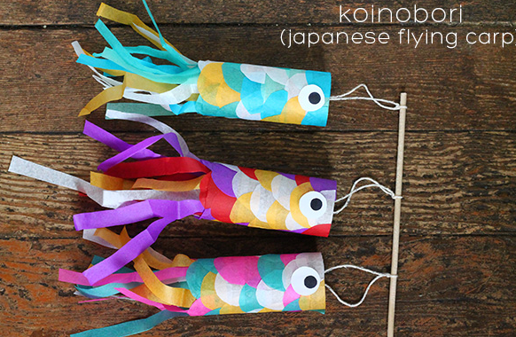

Science  YR: Find out about animals native to Japan. Create a shadow puppet of a Japanese animal. Explore how the shadow is made and how it changes. https://www.youtube.com/watch?v=yqmXAm1Cw3k  Y1: Animals from Japan. Click the links below to find out about different animal groups. https://www.bbc.co.uk/bitesize/topics/z6882hv  https://classroom.thenational.academy/lessons/what-are-the-differences-between-mammals-and-birds-6gvp8c https://classroom.thenational.academy/lessons/which-animal-families-are-vertebrates-ccw68c https://classroom.thenational.academy/lessons/what-types-of-food-do-living-things-eat-c4wkje  Choose an interesting animal native to Japan. Create a report to share with the class.  Y2: Humans and animals  Unit: Human lifestyle | Teacher Hub | Oak National Academy (thenational.academy) | Music-  EYFS: Have a listen to some traditional Japanese music and perhaps make a dance that you can film. https://www.youtube.com/watch?v=M40SBBsSCIA  https://www.youtube.com/watch?v=I_dktxCosN4  Explore traditional Japanese folk music  Tamba-Sasayama: Dekansho Bushi ~ Memories in a folk song ~ (Hyogo Pref.) | Japan Heritage  Click on the link with an adult to listen to the music. Then create your own music using drums if you have them. Record yourself, what other sounds could you add to your composition to add texture?  Traditional Japanese Music | Koi Pond | Shamisen, Koto & Taiko Music - YouTube | History-  No content
Computing- Y1 and Y2
Digital literacy

Digital literacy - KS1 Computing - BBC Bitesize
Spelling, Punctuation and Grammar- skills and movement activities

https://www.bbc.co.uk/teach/supermovers/ks1-english-reading-aloud-with-the-worst-witch/zh6cpg8
https://www.bbc.co.uk/teach/supermovers/ks1-english-alphabet-with-naomi-wilkinson/zjjy2sg

Maths – skills and movement activities

https://www.bbc.co.uk/teach/supermovers/ks1-maths-number-bonds-with-martin-dougan/zf6cpg8

https://www.bbc.co.uk/teach/supermovers/ks1-maths-digits-&-numbers-with-marlon-wallen/zfyjbdm

Geography

EYFS: Watch the video to explore life in Tokyo. Discuss the video with your grown up. https://www.bbc.co.uk/teach/class-clips-video/geography-ks1-ks2-your-world-tokyo-london/zv9pbdm
Take a look at this website to find out more about Japan. https://www.theschoolrun.com/homework-help/japan
Make a map of Japan using a medium of your choice.

Create a presentation about Japan using your choice of media! You could even create a scrapbook to share with the class!
With a grown up, click on the links below to access research information.
Japan facts - National Geographic Kids (natgeokids.com)
Geography of Japan (3dgeography.co.uk)
Animals Native to Japan - WorldAtlas
Japan’s Incredible Footbridges (unmissablejapan.com)

Times Table Rock Stars and Numbots Y1 & Y2

Practise your times tables online using the link below.
https://play.ttrockstars.com/auth/school

Log on to Numbots to practise a range of Mathematical skills. Passwords are in the front cover of Reading Diaries.

