Medium Term Planning for parents Summer 2 2021: Reception, Year 1, Year 2/ Y1 and Y2 when tasks are the same.
Topic- I do like to be beside the seaside.

Twinkl Parent Hub- free home learning activities
https://www.twinkl.co.uk/resources/parents

Maths  YR-Numbers to 20, Shapes and patterns.  Oak Academy links:  Doubling and halving https://classroom.thenational.academy/units/doubling-and-halving-7730  Grouping and Sharing https://classroom.thenational.academy/units/grouping-and-sharing-79a3  Shape and Pattern https://classroom.thenational.academy/units/shape-and-pattern-dba1  White Rose Links:  Odd and Even https://whiterosemaths.com/homelearning/early-years/find-my-pattern-week-3/  Sharing and Grouping https://whiterosemaths.com/homelearning/early-years/find-my-pattern-week-2/  Doubling https://whiterosemaths.com/homelearning/early-years/find-my-pattern-week-1/  KS1-https://whiterosemaths.com/parent-workbooks/  Y1: Counting in 2s. 5s and 10s.  Unit: Multiplication and division: 2, 5 and 10 | Teacher Hub | Oak National Academy (thenational.academy)  Count to and across 100.  Unit - Oak National Academy (thenational.academy)  Recognise, read and write numbers to 100.  Lesson: To recognise, read and write numbers to 100 | Teacher Hub | Oak National Academy (thenational.academy)  Identify and represent number using objects including a number line.  Unit - Oak National Academy (thenational.academy)  One more or one less  Lesson: To find one more or one less and ten more or ten less | Teacher Hub | Oak National Academy (thenational.academy)  Y2: 2, 5 and 10 times tables.  Unit - Oak National Academy (thenational.academy)  Counting on in 2s, 5s and 10.  Unit - Oak National Academy (thenational.academy)  Recognise, read and write numbers to 100.  Unit - Oak National Academy (thenational.academy)  Identify and represent numbers to 100.  Unit - Oak National Academy (thenational.academy)  Compare and order numbers to 100.  Unit - Oak National Academy (thenational.academy) | Religious Education-  Explore the following Bible stories. What is the significance and symbolism of water in these stories? What is the meaning of the story?  https://www.youtube.com/watch?v=oVy9HGr3Qig&list=PL5aPdmniG3y_n7hXEKTV4qQnIeCe-p6Ws&index=17 https://www.youtube.com/watch?v=7plJa_qnVug https://www.youtube.com/watch?v=K2t3-S6eSUU  Find out about Christian Baptism https://www.bbc.co.uk/bitesize/clips/zm87tfr | English  Daily reading and spelling practice (Weekly spelling lists on class webpage)  Reception  Write a diary of a visit to the Seaside.  Write a message in a bottle. What would it say? Why would you write to?  Practice reading and writing Phase 3 sounds- ow, oi, ear, air, ure, er. Can you find any objects in your house that have these sounds in them? Use the links below to help you practice.  Phonics with Geraldine the Giraffe https://www.youtube.com/channel/UC7sW4j8p7k9D_qRRMUsGqyw  Phonics play https://www.phonicsplay.co.uk/resources/phase/3  BBC Bitesize https://www.bbc.co.uk/bitesize/topics/zvq9bdm  Practice tricky word-they, are, all, you, my, was, her.  Practice forming letters and sounds and writing words using sand, paint, chalk, flour-whatever you like!  Make alphabet/sound cards and use them to make words using the phase 2 and 3 letter sounds we have learnt.  Y1 and Y2- Topic- I Do Like To Be Beside The Seaside! Y1 and Y2  Explore similes, write a simile poem about the seaside or an angry storm. Use dramatic and exciting word choices! Record yourself reading your poem using lots of expression and drama and send it into school!  What are metaphors and similes? - BBC Bitesize  Share the story 'The Little Mermaid’ by Hans Christian Anderson. Discuss the book, how might the mermaid's home have looked? What sort of character was she? Write setting and character descriptions using dramatic vocabulary.  Have you ever visited the seaside? Write about the day you went there. What did you see, hear or taste? How did the sea air smell? Did you have a paddle or swim in the sea? Write about your seaside adventure and draw a picture showing your adventure too!
Physical Education- Athletics
Personal bests:
Practise running for speed and direction
Practise jumping for distance and height
Practise throwing for accuracy and distance

Record your results in a data table. Which result are you most pround of and why? How could you improve your performance next time?
Art
Paint or decorate a shell. Use shells to create a piece of art. Here are some ideas to get you started https://www.playideas.com/25-summery-seashell-crafts-kids/
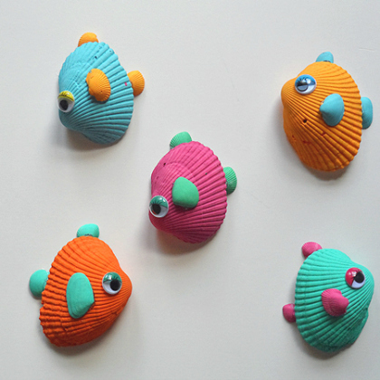
Create a seaside collage scene. Watch the video for inspiration! https://www.bbc.co.uk/programmes/p0114rt6
https://www.kapowprimary.com/subjects/art-design/key-stage-1/year-1/landscapes-using-different-media/
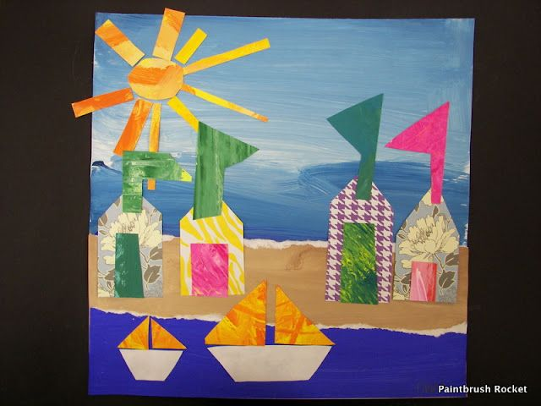
Design and Technology

Build a lighthouse.
https://littleheartsbiglove.co.uk/crafting-with-kids-a-simple-lighthouse-craft/

Make a healthy seaside picnic lunch.
Science  YR: What happens in Summer? https://www.bbc.co.uk/teach/class-clips-video/science-ks1-ks2-how-summer-weather-affects-behaviour-of-british-animals-plants/zkdkjhv What changes can you see? https://www.bbc.co.uk/bitesize/articles/zhtp2v4  Seasonal change STEM activities https://www.stem.org.uk/resources/community/collection/13195/year-1-seasonal-changes  Y1: What happens in Summer? https://www.bbc.co.uk/teach/class-clips-video/science-ks1-ks2-how-summer-weather-affects-behaviour-of-british-animals-plants/zkdkjhv What animals and plants can you spot in your garden?  Create a daily summer weather diary.  Record the times for sunrise and sunset in summer and compare to other seasons.  Identify and explore plants which grow at the seaside.  Seasonal change STEM activities https://www.stem.org.uk/resources/community/collection/13195/year-1-seasonal-changes  Y2: Explore the lifecycle of a butterfly. Look for signs of butterfly activity in your garden and complete sketches.  The butterfly life cycle! | National Geographic Kids (natgeokids.com)  Explore different types of butterflies and keep a bar chart of how many different ones you see.  Go on safari! Go outside and complete a bug hunt, what will you find?  Minibeast Hunt - Tips for Finding Bugs - Woodland Trust  Compare the habitats of a rockpool at the seaside and the micro habitat you have explored. Are the animals different or the same? Would the animals survive if they swopped habitats? Record yourself as a wildlife presenter discussing the best habitats for mini beasts and seaside creatures. | Music- Explore ‘Sun, Sea and Song!’  Primary Music KS1: Sun, sea and song! - BBC Teach  With a grown up explore sea shanty songs. Can you create your own? Record it and send it into school to share with te class! | History-  YR-Write 2 facts about what seaside holidays were like in the past and 2 facts about what they are like today.  Watch Magic Grandad https://www.youtube.com/watch?v=zWgnpY4L9so  Seaside history lesson https://www.youtube.com/watch?v=uK49rqKU30U  Y1 and Y2  Explore how the seaside has changed over time. Create a collage of an old-fashioned seaside using lots of different materials. Remember to send in a photo of your creation!  Draw a picture of the seaside and label it showing the beach, sea, cliffs. Make it colourful!  Read the book The Lighthouse Keepers Lunch. Why do we have lighthouses? Why are they helpful? How have their uses changed over the years? Find lighthouses at different U.K seaside locations. Become a reporter and record yourself reporting on lighthouses. Send your film in for the class to watch it!  Robert Stevenson and Lighthouses - BBC Bitesize
Computing- Coding- Scratch Jr

Download the free Scratch Jr App to explore coding and play some great games!
ScratchJr - Home

Spelling, Punctuation and Grammar- skills and movement activities

https://www.bbc.co.uk/teach/supermovers/ks1-english-reading-aloud-with-the-worst-witch/zh6cpg8
https://www.bbc.co.uk/teach/supermovers/ks1-english-alphabet-with-naomi-wilkinson/zjjy2sg

Maths – skills and movement activities

https://www.bbc.co.uk/teach/supermovers/ks1-maths-number-bonds-with-martin-dougan/zf6cpg8

https://www.bbc.co.uk/teach/supermovers/ks1-maths-digits-&-numbers-with-marlon-wallen/zfyjbdm

Geography

YR-Watch Barnaby Bear’s visit to the Seaside-Poole. https://www.bbc.co.uk/programmes/p0113z8j Draw a picture or create a map of Poole-use geographical terms such as harbour, bridge, cliff to describe.

Y1 and Y2

Using a map locate the seasides that you have visited. Which one is the furthest from your home? Which one would you like to visit next and why?

Draw a line between two points on the map below. Where have you come from and where are you going to? Describe your journey, what will you see on the way?
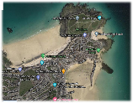

Times Table Rock Stars Y1 & Y2
Practise your times tables online using the link below.

https://play.ttrockstars.com/auth/school
Login- Sheriffhales , it will come up automatically when typed, select this.
Username- first three letters of first and second name, no spaces and all lower- case letters.
Select Gig/ Garage for daily practise. Select Studio to develop speed. Both games are updated automatically as the children progress in knowledge of tables and speed.

