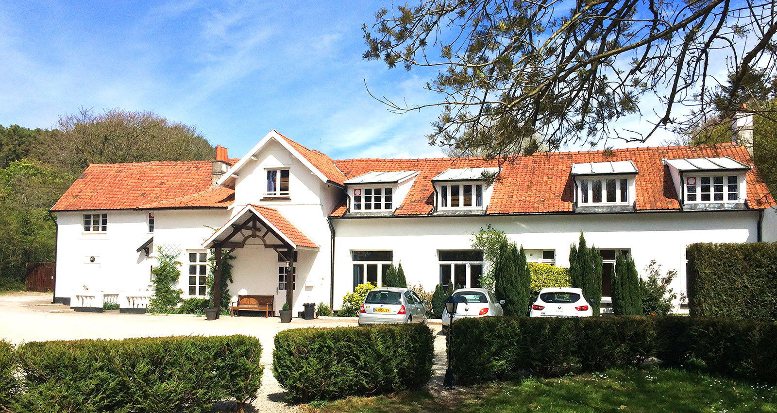
Le Pre Catalan
Just 32 miles from Calais and a 10 minute walk from the beach at Hardelot-Plage, Le Pré Catelan is ideal for primary school groups on their first trip to France. Groups love to visit the local places of interest nearby - traditional shops, Boulogne Market and Nausicaa Sealife Centre to name just a few.

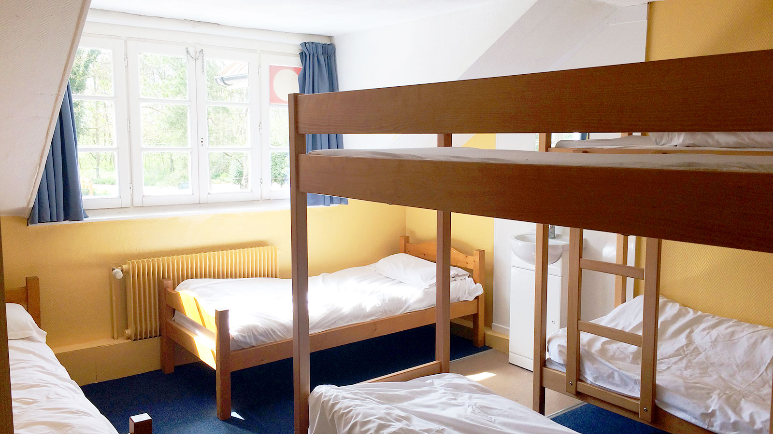
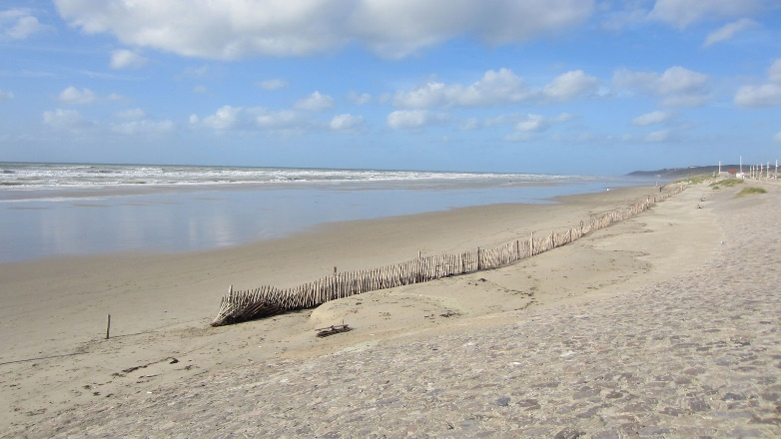
Cote d‘Opal
- Full board accommodation
- Door-to-door transport and use of executive coach throughout our stay.
- Varied evening entertainment programme
- Accompanying adults on a 1:8 ratio
Les escargots!

Le Pré Catelan 5 day mid-week Package
Monday | Arrive 16:30-19:00, welcome tour  Evening entertainment
Tuesday | AM : Boulangerie visit  PM : Les Escargots du Bocage  Evening entertainment
Wednesday | AM: Boulogne Market & town trail  PM: PGL activities  Evening entertainment
Thursday | AM: Chocolaterie de Beussent  PM: PGL activities  Evening entertainment
Friday | Depart after breakfast with hypermarket stop en-route

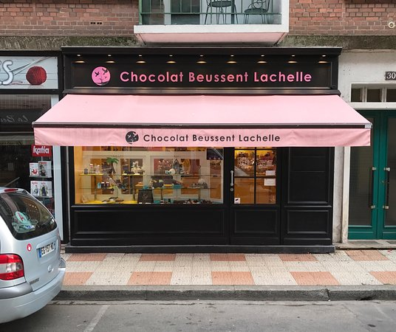
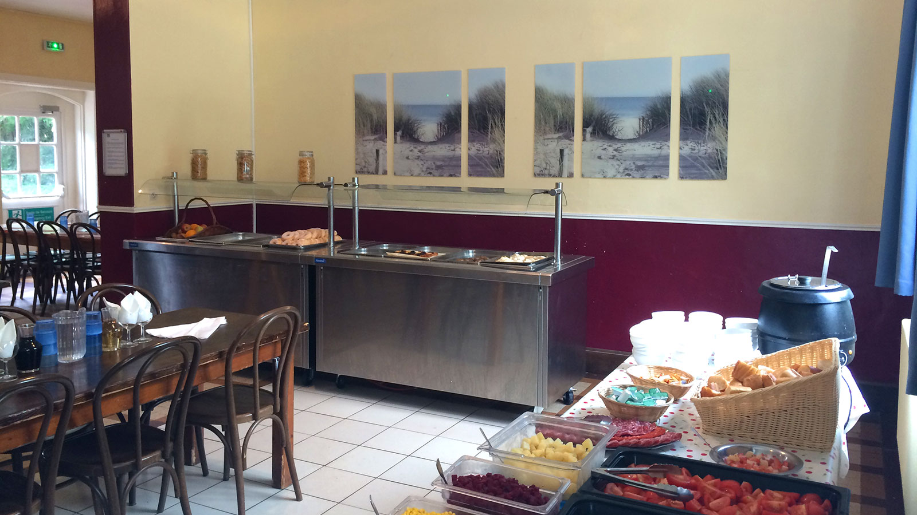 I spy doughnuts!
Locally sourced, tasty meals with a French flavour!
Our delicious menus provide a balance between the familiar and the opportunity to try food with a distinctly French flavour too - snails anyone?
- Hot and cold meals with vegetarian options
- Fresh croissants at breakfast
- Homemade soup every day
- Self-service salad bar
- Fresh fruit with every meal
- Allergies, intolerances and special diets catered for
- Support for fussy eaters

Sample menus
